1. **Dynamic ports:**

Json file from github. No change to the file.

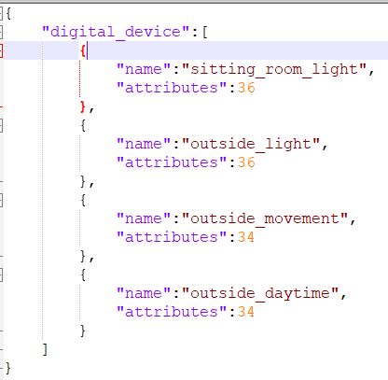

gds.config working example with some modification

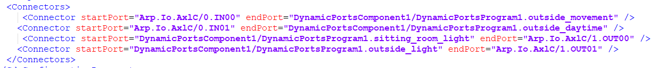

I have a simple logic to enable sitting room light and outside light per IN00 and IN01. This works as expected.

**2: IEC ports and C++ variables.**

Created ports in PLCNext

My idea of using IEC and C++ ports:

IN00 – Outside_mvt (IEC) – Outside_movement (C++)

IN01 – Outside_DT (IEC) – Outside_daytime (C++)

OUT00 – Sitting_room (IEC) – sitting_room_light (C++)

IN00 – Outside_lgt (IEC) – Outside_Light (C++)

I created the IN and OUT ports in the IEC program and assigned it to the IO. However, PLC does not run and have errors in the output log. Please see below for screenshots.

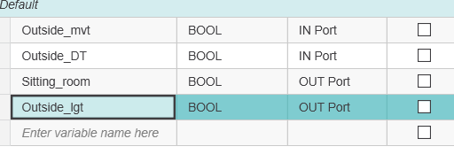

**Port List:**







Gds config file on the PLC:

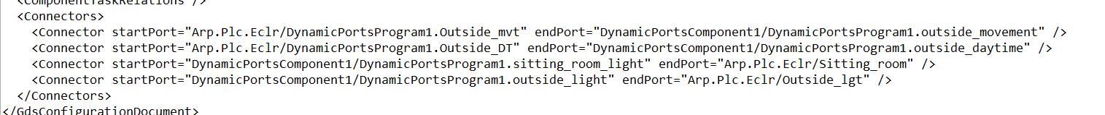

Output log:

